Economics Model Representation – 1-Page Summary Report

Problem Statement
An economics / marketing analyst needs to understand and implement the fundamental linear model f_w,b(x) = w·x + b that relates advertising expenditure to sales revenue. With only two historical campaigns (Ad Spend 1.0 → Sales 300; Ad Spend 2.0 → Sales 500, units of $10k), the analyst must (1) represent the model in code, (2) visualize the economic relationship, (3) discover parameters that fit the observations, and (4) produce a sales forecast for a new $12k advertising budget.

Solution Strategy
- Define training arrays x_train (ad spend) and y_train (sales) and inspect m, individual examples.
- Scatter-plot the two campaigns to confirm a linear economic relationship.
- Implement compute_model_output both with an explicit loop (pedagogical) and a vectorized NumPy expression (production-ready).
- Experimentally discover the unique parameters w = 200, b = 100 that pass through both points.
- Predict sales for a new budget x = 1.2 and quantify sensitivity of the forecast to ±10 % changes in w and b.
- Add residual checks, a third synthetic point, and a multi-line simulation plot for intuition.

Solution
The fitted response function is Sales = 200 × AdSpend + 100. For a new advertising budget of 1.2 units ($12,000) the model forecasts 340 units of sales revenue (≈ $3.4 M if each unit equals $10 k). Residuals on the original data are exactly zero; the vectorized and loop implementations produce identical outputs.
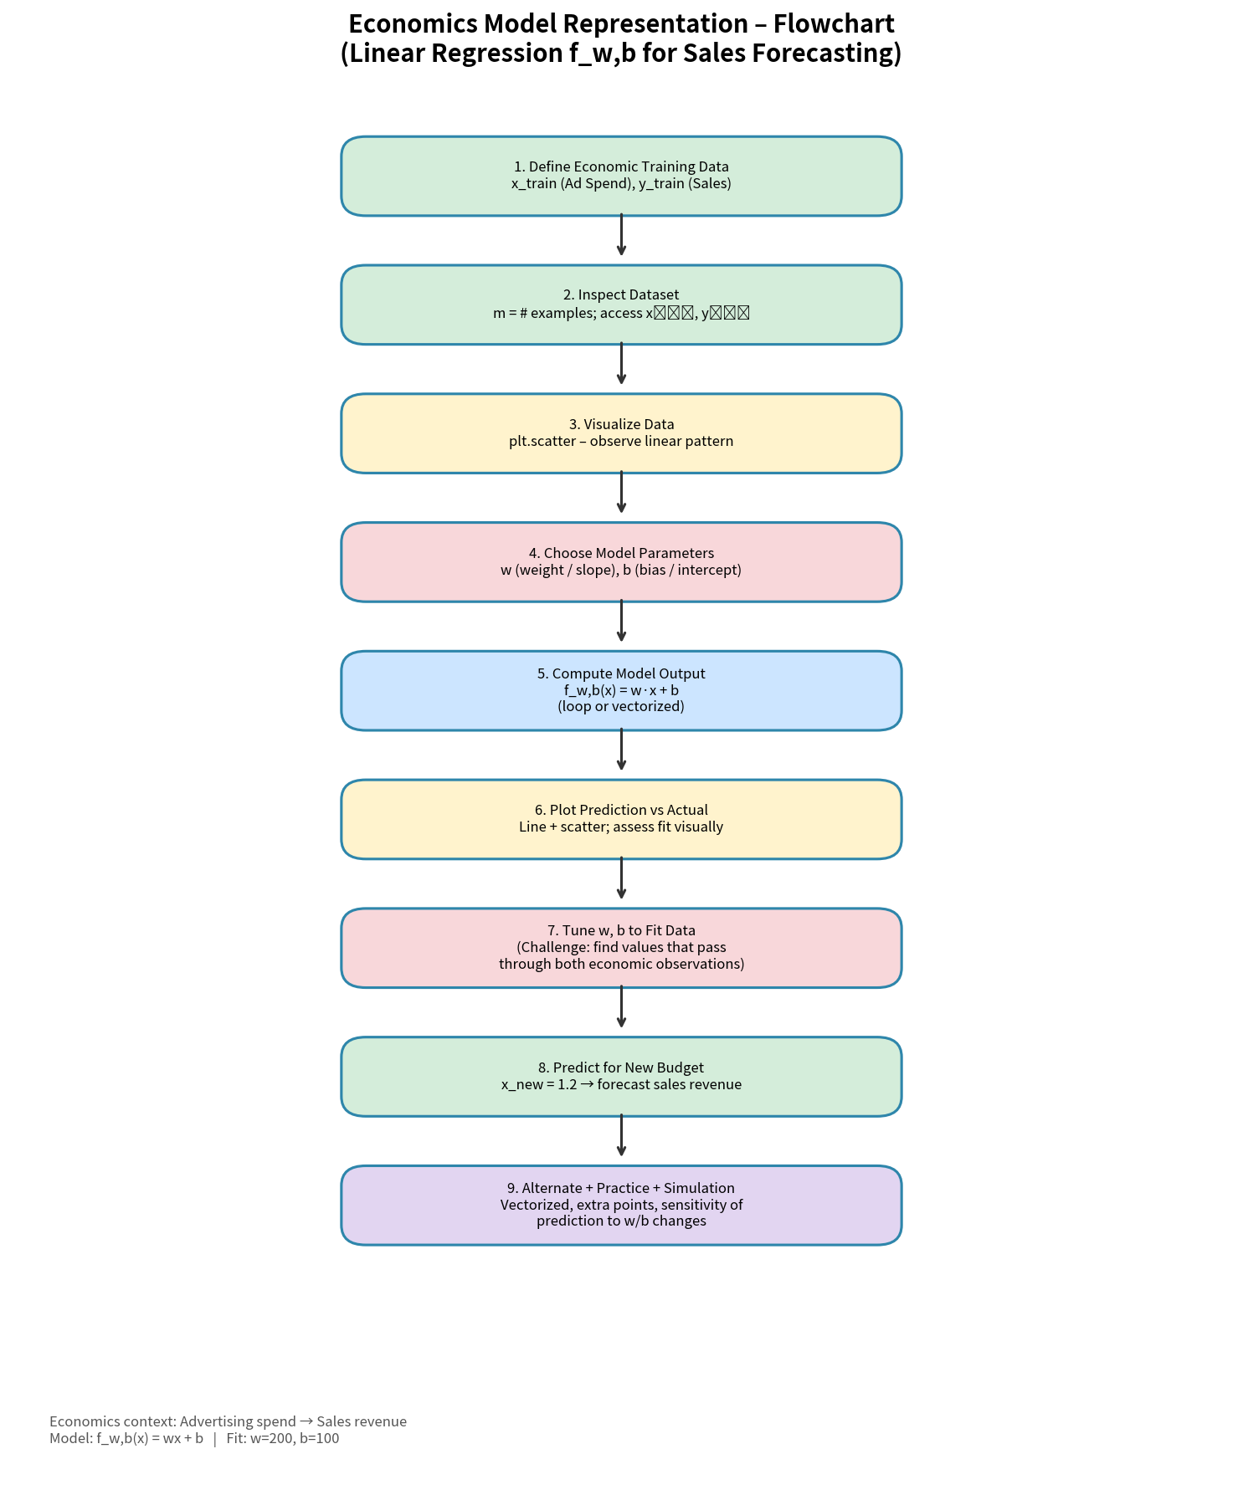
Figure 1 – Workflow flowchart (data → model → fit → forecast → simulation)
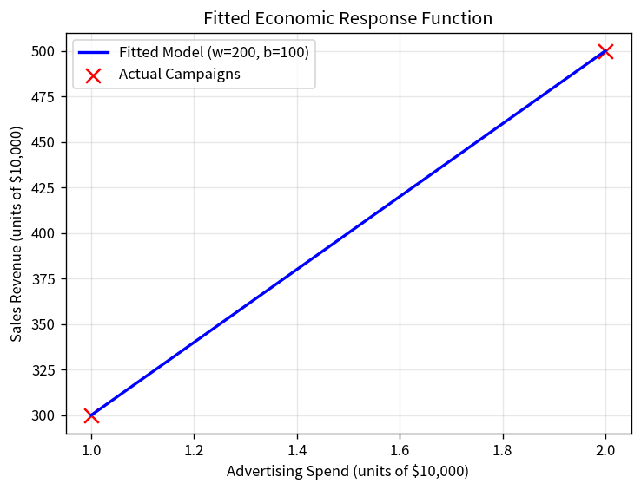
Figure 2 – Fitted economic response line through the two observed campaigns
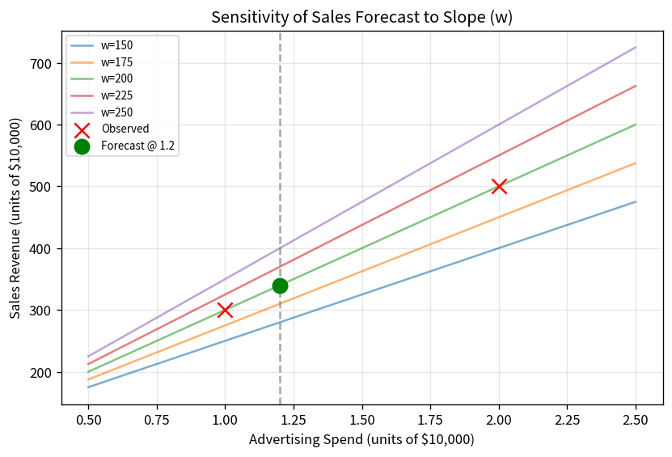
Figure 3 – Sensitivity of the sales forecast to alternative slopes (w)

Key Takeaways
- The two-parameter linear model f_w,b(x) = wx + b is the simplest yet most widely used response function in managerial economics and marketing-mix modelling.
- With two non-collinear points the parameters are uniquely determined; more data would require a cost function and optimisation (gradient descent).
- Vectorized NumPy code is concise and fast; the explicit loop remains valuable for teaching the element-wise definition of the model.
- A short parameterised simulation quickly reveals that a 10 % error in the slope moves the $12 k-budget forecast by ±24 sales units – useful for risk communication to executives.
- Audience adaptation matters: analysts appreciate residuals and sensitivity tables; executives want the single headline forecast and one clean chart.

